Unidos, Nabas, Aklan Philippines 5607

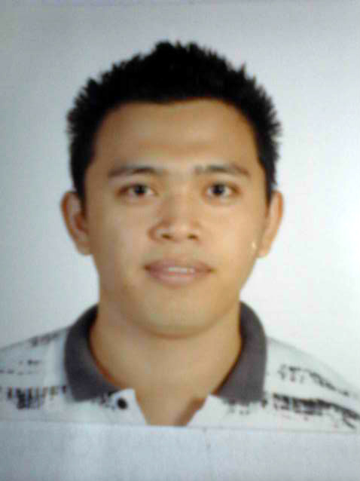

Bernel Mariano Sadiasa

PERSONAL COLUMN:

Age : 28
Date of Birth : November 23, 1986
Gender : Male
Nationality : Filipino
Civil Status : Single
Height : 176 cm
Weight : 76 kls.
Religion : Born Again Christian
Language Spoken : English, Tagalog and Arabic
Permanent Address : Unidos, Nabas, AKlan Philippines 5607

EDUCATION

Primary : Unidos Elementary School 1994 - 1999
Unidos, Nabas, Aklan Philippines
Secondary : Unidos National High School 1999 – 2003
Unidos, Nabas, Akan Philippines
Course : Bachelor of Science in Industrial Technology
Major in Electronics Technician
Aklan State University (A.S.U) 2003 - 2007
Kalibo Akaln Philippines

Career Objective/Summary: To be able to utilize and contribute to the welfare of the company as a team or as an individual, talents and skills to achieve its objective. To enhance my capability in carry out any machine set-up, preventives maintenance and troubleshooting in order to maximize equipment productivity.

WORK EXPERIENCED:

Position : Communication Technician
Duration : July 09, 2012 up to August 30, 2014
Company : First Gulf Company (FGC)
Location : Royal Justice Palace
Riyadh K.S.A
Department : Operation and Maintenance
Job Description: - Performing Telecom and Electronics work.
- Perform basic program of SAUDI ERICSSON system and
STC system.
- Performs investigation, analysis, troubleshooting calibration
And repair works for each reported problem.
- Responsible to all Ericsson extension lines and STC direct
lines.
- Equipment as required troubleshooting repair.
- Perform scheduled preventive maintenance monitoring costs
And quality to insure that they meet the target and objectives
Set by the superior.

Position : Electronics Technician
Duration : November 03, 2007 up to May 19, 2012
Company : MFLE TRADING Dealer of Japan Surplus Appliances
Sales and Rental Videoke and Videogames
Location : No. 8 Rose St. Area 9 Luzon Ave. Pasong Tamo Quezon
City
Department : Buy and Sales
Job Description: - Responsible of repairing of all kind of appliances.
- Responsible of all machine repair.
-Ensure that the working environment is safe and conductive
work.
-Making improve proposal on work related matters.

Position : Maintenance Technician
Duration : May 15, 2007 up to October 18, 2007
Company : SERAPH HOTEL and RESORT
Location : Boracay Island Malay, Aklan Philippines
Department : Operation and Maintenance
Job Description: -Responsible of all safety of electricity.
-Operates of generators to supply the 1200 rooms.
-Plumbing, Air-condition, Carpenter, Electricians, Telecom
Technician and the Special Electronics Technician.
-Installation of all the sounds system in KTV bar and the
main area of dinning.

SEMINARS AND TRAININGS ATTENDED

On the job training
Aklan State University
888 BBB TRADING AND SALES
September 08, 2006 up to February 08, 2007
Electronics Technician

World Class Filipino Workforce
Executive Technical Consultants Trade Test and Training Center INC.
March 30 – April 2, 2012
Maintenance Technician
B+

SKILLS

Knowledge in Troubleshooting and Repairing of all Electronics Appliances.
Knowledge in Electrical and Mechanical works.
Knowledge in Repairing and Troubleshooting of Elevator (THYSSENKRUPP COMPANY)
Knowledge in computer such as Microsoft office word and Microsoft office excel.

PERSONAL DESCRIPTION

I am dynamic and active, strong-willed and decisive, unemotional, independent, compulsive need for change. Goal-oriented, organizes well, often sees the whole picture and seeks practical solutions. I am spontaneous, insist on production, stimulate activity and strive for success. I can say that I am usually right but willing and open for suggestions and corrections in order to attain success in every work I do. More often excel during emergencies; perform well alone but will also work for a group activity and optimist

REFERENCES:

Engr. Ahmed Mirghani ahmed General Support Services Manager
Operation Maintenance
First Gulf Company (FGC) Relationship: Co Worker

Engr. Audie B. Dulatre Elevator Engineer
THYSSENKRUPP, K.S.A
Relationship: Co worker

Engr. Robin Espanola Communication Engineer
Saudi Ericsson Communication Company Ltd.
Relationship: subcontract on the Telecom
Engr. Edwin Villafria Communication Engineer
Saudi Ericsson Communication Company Ltd.
Relationship: subcontract on the Telecom

Manager Elpidio Mercado Owner and Manager
MFLE TRADINDS Dealer of Japan Surplus
Appliances
Relationship: Co worker

I hereby affix that the above information is true and correct to the best of my knowledge and belief. GOD BLESS and MORE POWER!

BERNEL M. SADIASA

