B.SELVAGANAPATHY 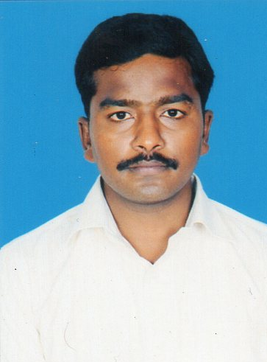

Email:selva.ganapathy1988@gmail.com.
CELL NO: +919962128550, +919840422805.
Skype:Selva_ganapathy141

OBJECTIVES :

To work to the best of my knowledge and abilities in the best interest of the organization such that both the company and myself grow in the most efficient manner towards a better future.
EDUCATION QUALIFICATION:

- HSC

TECHNIAL QUALIFICATION:

- INDUSTRIAL TECHNICAL INSTITUTE-2 Year Course .

- ELECTRICAL AND ELECTRONICS

SKILL SET:

- Ability to work in a team

- Ability to work under pressure

- Ability to work on shifts

- Ability to handle crisis
- Ability to handle low current and High Current systems.

EXPERIENCE :

Company Name : P.S. ELECTRICAL (p) LTD CHENNAI
Duration : From Nov 2007 to Feb 2009

Company Name : VICTORY ELECTRICALS LTD CHENNAI
(Formerly Hack Bridge-Hewittic Easun)
Duration : From Mar 2009 to March2012

Company Name : ERAM INDUSTRIAL GROUPS Saudi Arabia
Duration : From April – 2012 to Jun-2014
Company Name : COLLIERS INTERNATIONAL(Express Avenue Chennai )
Duration : Oct 2014 to Till Now.
JOB RESPONSIBILITIES

Having experience in the following
- operating and maintenance for 2000KVA Transformer.
- operating and maintenance for 1500KVA DG set.
- operating and maintenance for UPS.
- operating and maintenance for AHU.
- Parellel operation for Transformer to DG.
Electrical equipments fitting and checking.
KWH Ammeter,Voltmete,P.F.meter and reading and checking.
- Tapping lead arrangement.
- Complete brazing of LV & HV connections.
- Complete assembly of on load tap changer including diverter switch fixing and shaft alignment.
- Mounting of bushing up to 230 KV class.
- Operator for the vacuum drying plant operator.
- Help of customer inspection.
- Experience & knowledge in transformer failure investigation and analysis.
- Experience & knowledge in transformer manufacturing processes and procedure.
- Power Transformer RTTC and Marshaling box wiring works
- power Transformer operating for the oil filtration machine ( 6000 liter/hour)

HVAC EXPERIENCE
- HVAC duct drawing arrangement and checking
- Ducting box arrangement and installation
- Tighten and clamping duct fitting.
- Damper and fire damper fitting and shoe coaler fitting
- Supply air and reverse air grill fitting and fresh air damper grill fitting.
- Dry water pipe connection.
- HVAC Sound silencer fitting and air flow checking.
- Cable tray arrangement and fitting.
- HVAC control cable lay outing
- HVAC , RTTC panel installation.
- Able to handle Low Voltage and High Voltage Systems.
PERSONAL INFORMATION:

Name : B.SELVAGANAPATHY

Mobile : +919962128550

Father’s Name : G. Balasubramaniyam

Address : B2-F1, Crest Heritage Gandhisalai,
Manikandan Nagar Extn, Metrorcity,
Kundrathur
Chennai - 600069.

Date of Birth : 06/04/1988

Gender : Male

Languages Known : English, Tamil , Hindi (speak)

Passport Details

Passport No : H6884305

Place of Issue : Trichirapalli

Date of issue : 23/11/2009
Date of Expiry : 23/11/2019

DECLARATION:

I assure all the information and facts furnished above are true to the best of my knowledge and any legal action could be taken if they were provided to be false

Place : Yours Faith Fully
Date :
(SELVAGAPATHY.B)

