  Employee Performance Review  Annual Mid-Year |  |  |  |  |  |  | 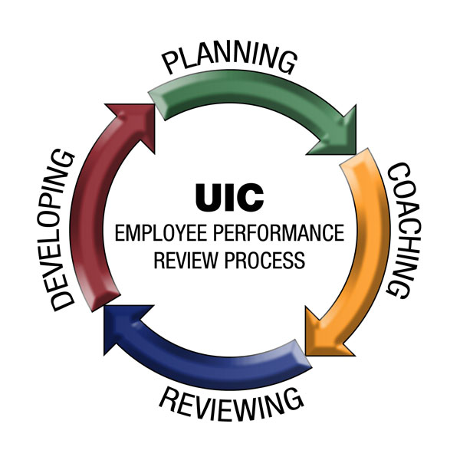
Employee Information
 | Employee Name: |  |  |  | College/Unit:
 | Manager Name: |  |  |  | Review Period:
Performance Review Summary
Section I: UIC Core Competencies | / 15
Section II: Essential Job Functions | + / 12
Total = | / 27
Summary Matrix
23 – 27 Points | Exceeds Expectations
14 – 22 Points | Meets Expectations
7 - 13 Points | Does Not Meet Expectations*
* Recommends Performance Improvement Plan (PIP)

Performance | Performance Definition
Exceeds Expectations | - Significantly and consistently (more than 50% of work hours) exceeds expectations and role requirements defined in the Job Description (if available)  - Demonstrates exceptional depth and breadth of knowledge, highly recognized by others within the University community  - Demonstrates role model behavior for other supervisors/staff to emulate
Meets Expectations | - Meets and occasionally exceeds expectations and role requirements defined in the Job Description (if available)  - Demonstrates willingness to collaborate with peers, managers, students and customers consistently
Does Not Meet Expectations | - Does not meet expectations and role requirements defined in the Job Description (if available) on a consistent basis (more than 50% of work hours)  - Requires more than the expected level of supervision  - Exhibits consistent (i.e., one or more documented actions per month) inappropriate work behavior while interacting with peers and/or management

Performance Review Guidelines
The completed Employee Performance Review forms are to be filed in the college or unit confidentially and separate from employee personnel files. Do not return to UIC Human Resources. Employee Performance Reviews should be maintained as they may be requested during an audit.

Signatures
Employee Signature: This review has been discussed with me (signature does not imply agreement with the review).
 | Employee |  | Date |  | Manager |  | Date
 | Department Head (if applicable) |  | Date

Section I: UIC Core Competencies (Comments are required for Exceeds Expectations and Does Not Meet Expectations)
Customer Service: Is dedicated to listening and meeting internal and external customers’ expectations and needs; responds to the customer in a timely manner; and demonstrates respect for all individuals regardless of their background, culture or organizational level.
Expected Behaviors:
- Demonstrates respect for all employees
- Assists customers with their needs in a positive and timely manner
- Understands internal and external customers needs
- Addresses customer requests in a professional, positive and effective manner
 |  |  |  | Comments:  Opportunities for Improvement:
  Exceeds Expectations (3)
  Meets Expectations (2)
  Does Not Meet Expectations (1)
Integrity: Instills mutual trust and confidence; creates a culture that fosters high standards of ethics; is consistent and follows-through; and demonstrates a sense of university responsibility and commitment towards the UIC values: Knowledge, Access, Openness, Excellence and Collaboration.
Expected Behaviors:
- Upholds the UIC values: Knowledge, Access, Openness, Excellence and Collaboration
- Behaves ethically through responsible use of time and UIC property
- Behaves in a fair and ethical manner toward others
- Follows-through on professional commitments

 |  |  |  | Comments:  Opportunities for Improvement:
  Exceeds Expectations(3)
  Meets Expectations (2)
  Does Not Meet Expectations (1)
Cooperation: Establishes and maintains effective working relationships within the college/unit and with supporting colleges/units; makes suggestions to improve efficiency and effectiveness of the work team; demonstrates flexibility and willingness to assist by taking on difficult or challenging tasks or projects.
Expected Behaviors:
- Maintains a positive approach, works cooperatively with others as a team
- Demonstrates a constructive response to criticism
- Works with other colleges, units and/or departments to resolve issues
- Assists others in completing their tasks as needed
- Understands and effectively adjusts to change; assists others in understanding and accepting change

 |  |  |  |  | Comments:  Opportunities for Improvement:
  Exceeds Expectations (3)
  Meets Expectations (2)
  Does Not Meet Expectations (1)
Accountability: While addressing job-related responsibilities, confirms established processes are followed. Accomplishes job related tasks and goals by adhering to policies and procedures. Accepts responsibility for actions and engages in appropriate behavior to address work-related issues associated with job.
Expected Behaviors:
- Demonstrates ability to notify others of his/her actions that may conflict with UIC’s processes
- Takes responsibility for work products, services and results; does not shift blame on others
- Confirms measures to assess college, unit, department, program or project effectiveness
- Monitors goals and objectives in a systematic, timely manner and takes necessary action to address areas of concern
- Encourages others to take ownership of work products, services and results
 |  |  | Comments:  Opportunities for Improvement:
  Exceeds Expectations (3)
  Meets Expectations (2)
  Does Not Meet Expectations (1)
Communication: Expresses ideas and information in a written and/or oral manner effectively; facilitates an open exchange of ideas and fosters an atmosphere of open communication; shares information and resources with others as appropriate in a timely manner.
Expected Behaviors:
- Presents verbal expression in a clear, positive and appropriate manner
- Presents grammatically correct written material
- Follows up as appropriate to ensure understanding
- Adapts communication for target audience

Exceeds Expectations (3) |  | Comments:  Opportunities for Improvement:
Meets Expectations (2)
Does Not Meet Expectations (1)
Total Score: / 15

Section II: Essential Job Functions (Comments are required for Exceeds Expectations and Does Not Meet Expectations)
Job Knowledge
Expected Behaviors:
- Demonstrates the knowledge and skills necessary to perform the job
- Performs responsibilities in accordance with job description, procedures and policies
- Acts as a resource person (as necessary) upon whom others rely for assistance
- Understands the expectations of the job and remains current regarding new developments in areas of responsibility
- Demonstrates skills necessary to meet job requirements

 | Comments:  Opportunities for Improvement:
  Exceeds Expectations (5-6)
  Meets Expectations (3-4)
  Does Not Meet Expectations (1-2)
Work Quality
Expected Behaviors:
- Completes assignments in a thorough, accurate and timely manner achieving defined outcomes
- Meets established goals successfully
- Exhibits concern for the goals and needs of the department and others that depend on services or work
- Handles multiple tasks and uses work time effectively to maximize personal productivity
- Delivers high quality work product with few errors
- Prioritizes responsibilities based upon changing needs of the college/unit

 | Comments:  Opportunities for Improvement:
  Exceeds Expectations (5-6)
  Meets Expectations (3-4)
  Does Not Meet Expectations (1-2)
Total Score: / 12

Section III: Performance Goals (At least one goal recommended, but no more than three job goals annually)
Goal 1:
Action Plan (e.g. specific actions to enhance growth as related to the defined goal):
Measure (e.g. what will be observed and assessed to determine progress toward achieving the goal and goal achievement):
Target Goal Date (e.g. date defined goal is achieved):
Result:

Goal 2:
Action Plan (e.g. specific actions to enhance growth as related to the defined goal):
Measure (e.g. what will be observed and assessed to determine progress toward achieving the goal and goal achievement):
Target Goal Date (e.g. date defined goal is achieved):
Result:

Goal 3:
Action Plan (e.g. specific actions to enhance growth as related to the defined goal):
Measure (e.g. what will be observed and assessed to determine progress toward achieving the goal and goal achievement):
Target Goal Date (e.g. date defined goal is achieved):
Result:

Employee Comments (This space may be used for the employee who is being reviewed to make comments if they wish. This section is not required to be completed.)

