S.No | Electrical_ Electronic _ Insrumentation Tools | Name of the tool or Product Name | Quantity | Rate
1. |  | Allen key set
2. | 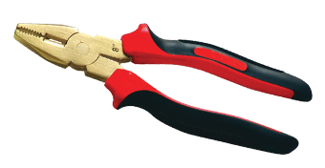 | Cutting Plier
3. | 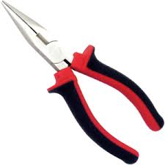 | Nose cut plier
4. | 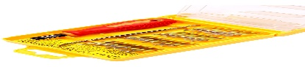 | Electronic screw Driver Set
5. | 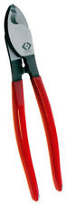 | 6 inch Cable cutter
6. | 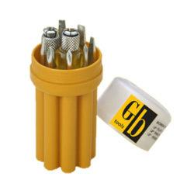 | Screw driver set model 1
7. | 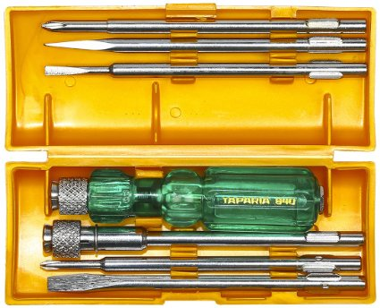 | Screw driver set Model 2
8. | 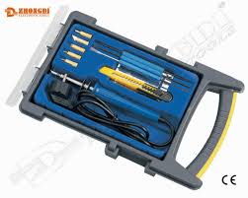 | Soldering iron set
9. | 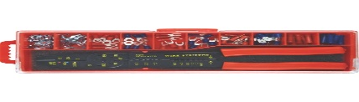 | Terminal crimping tool
10. | 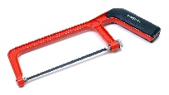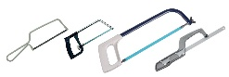 | Hack saw normal and mini
11. | 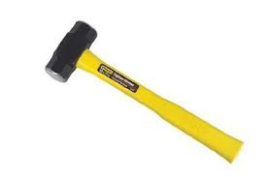 | Hammer 1 pound
12. | 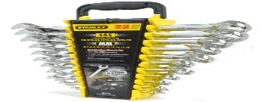 | Spanner Set
13. | 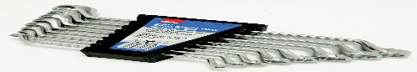 | Rings Spanner
14. | 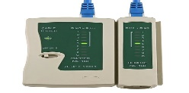 | LAN Tester
15. | 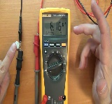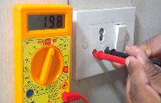 | Digital Mutlimeter Fluke or Local (Ac,Dc)
16. | 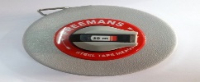 | 5 meter and 30 meter
17. | 
18. | 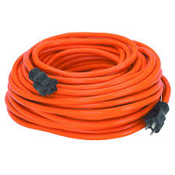 | Extension Cable
19. | 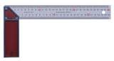 | Trisquare
20. | 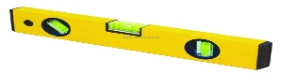 | Sprit level (Small)
22. | 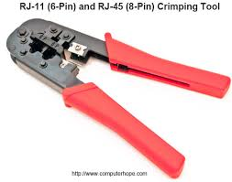 | RJ 45 Crimping tool
23. | 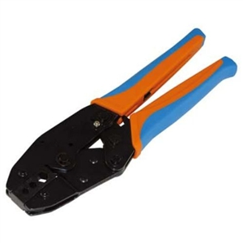 | Coaxial cable crimping tool
24. | 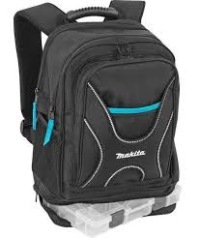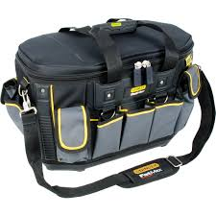 | Tool Bag

25.

26.

27.

28.

29.

30.

32.

